**Institute of Technology Tralee**

**Ord/Hons BSc. in Computing with Specialism (Sample 2) - Year 1**

**Continuous Assessment #1**

**Date:**

**Time:**

**Object Oriented Programming 1**

**Instructions:** Attempt the following question. You should use the JCreator IDE. When you are finished coding, print out your code in **landscape** format.

**________________________________________________________**

**Q1.**

In numerology, it is possible to come up with the so-called “life-path” number by taking the date of birth and adding up its digits as indicated in the following examples:

**Example 1: Date of birth is 23/06/1977**

23 becomes 2+3 to give 5

06 becomes 0+6 to give 6

1977 becomes 1+9+7+7 to give 24 which in turn becomes 2+4 to give 6

Now add these individual sums to get 5+6+6 which gives 17 which in turn becomes 1+7 to give a life-path number of 8.

**Example 2: Date of birth is 04/12/1966**

04 becomes 0+4 to give 4

12 becomes 1+2 to give 3

1966 becomes 1+9+6+6 to give 22 which in turn becomes 2+2 to give 4

Now add these individual sums to get 4+3+4 which gives 11.

Note that if the result of adding the individual sums is 11 or 22 then there is no further addition required, these are the actual life-path numbers in these cases. They are the only 2 digit life-path numbers.

To convert a character to its numeric equivalent you just need to subtract 48 from its ASCII code e.g. if the date of birth is 04/12/1966 then the character ‘6’ in the year part can be converted to the integer 6 by using the expression **(int) ‘6’ – 48**. You may find this useful when calculating the individual sums (although there are other ways to do it).

You must write a program that reads in the date of birth of a person in the form dd/mm/yyyy in the main(), and then call a user-defined method **lifePathNumber**() which takes as an argument the date of birth entered. The method should then use the technique described above to determine the life-path number. Once this value is returned as an integer to main(), the life-path number should be displayed. Note that you **do not need to validate the date of birth** value in any way.

For full marks your program should, along with a logically correct solution for the problem above, include **comments** and **meaningful variable names**.

Your program should run exactly as indicated in the following sample screenshots. Also, you should use the test values indicated when testing your own program. Note that the screenshots below only test a few of the many possibilities so make sure you **test your program fully**.

**Sample Screenshots**

**Run 1 – date of birth 23/06/1979**

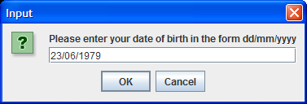 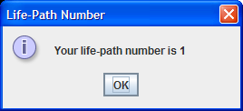

**Run 2 – date of birth 04/12/1966**

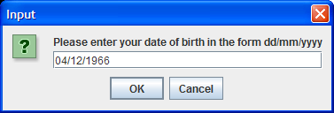 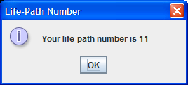

**Run 3 – date of birth 21/11/1947**

